**Creating Microservices for account and loan**

Create the account Microservice

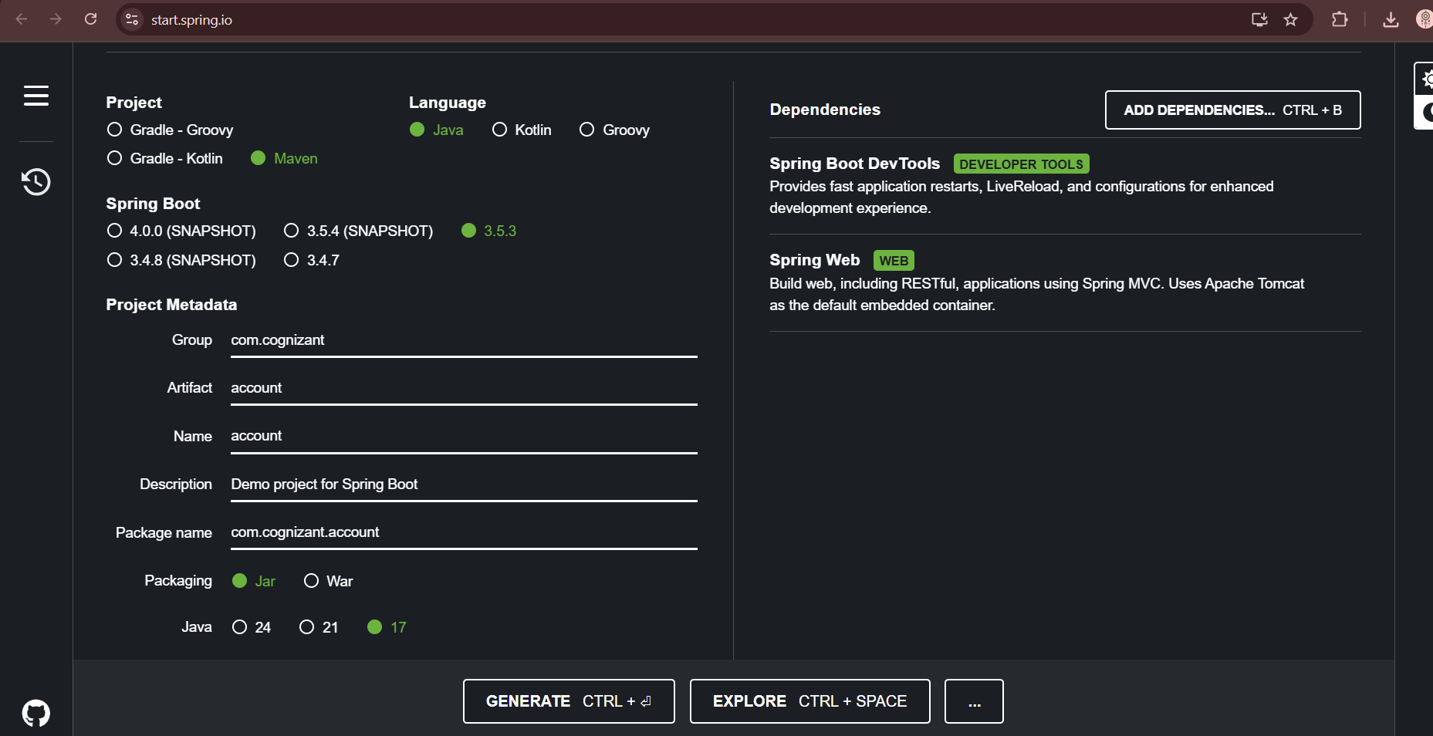

It downloads a file named like account.zip, Extract account.zip and Move that account folder into microservices folder

Build account Project

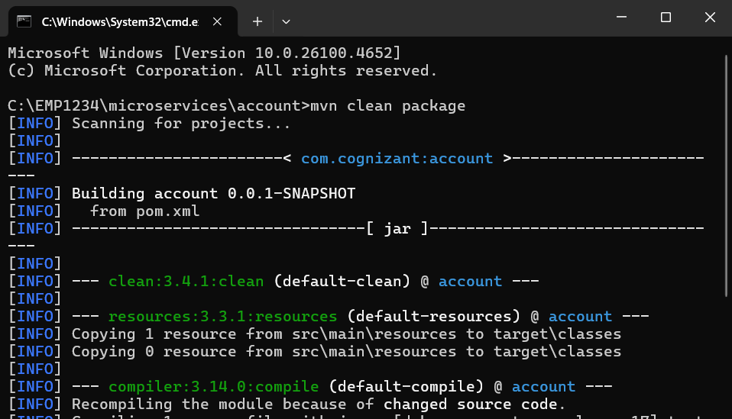

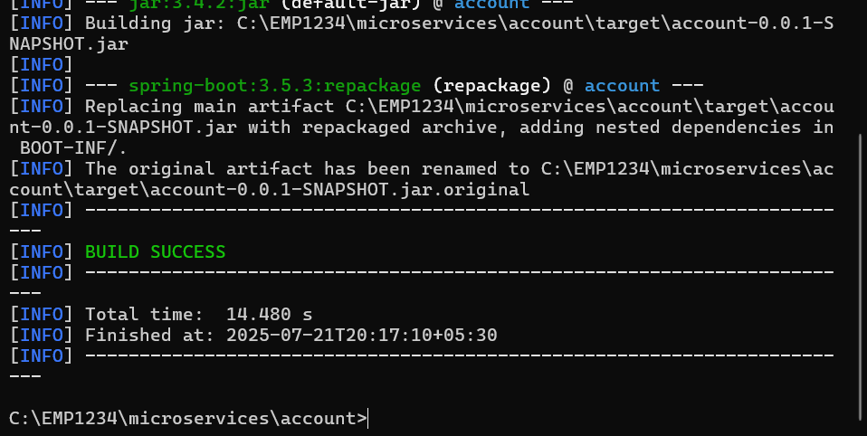

Imported account in Eclipse and added Controller for account

src/main/java/AccountController

package com.cognizant.account;

import org.springframework.web.bind.annotation.GetMapping;

import org.springframework.web.bind.annotation.PathVariable;

import org.springframework.web.bind.annotation.RestController;

*@RestController*

public class AccountController {

*@GetMapping*("/accounts/{number}")

public Account getAccountDetails(*@PathVariable* String number) {

return new Account(number, "savings", 234343);

}

static class Account {

private String number;

private String type;

private double balance;

public Account(String number, String type, double balance) {

this.number = number;

this.type = type;

this.balance = balance;

}

public String getNumber() { return number; }

public String getType() { return type; }

public double getBalance() { return balance; }

}

}

AccountApplication.java

package com.cognizant.account;

import org.springframework.boot.SpringApplication;

import org.springframework.boot.autoconfigure.SpringBootApplication;

*@SpringBootApplication*

public class AccountApplication {

public static void main(String[] args) {

SpringApplication.*run*(AccountApplication.class, args);

}

}

• Right-click the project → **Run As → Java Application**

Open a browser

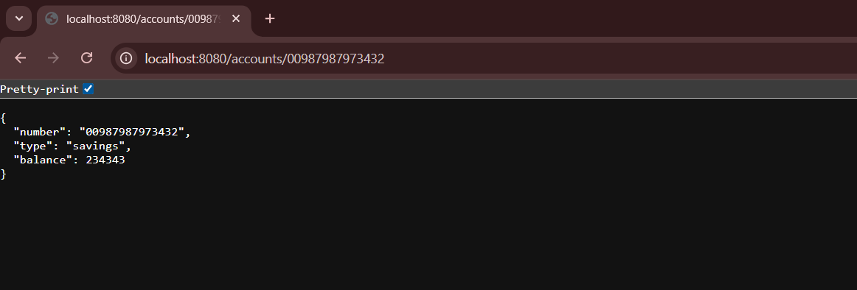

Create loan Microservice

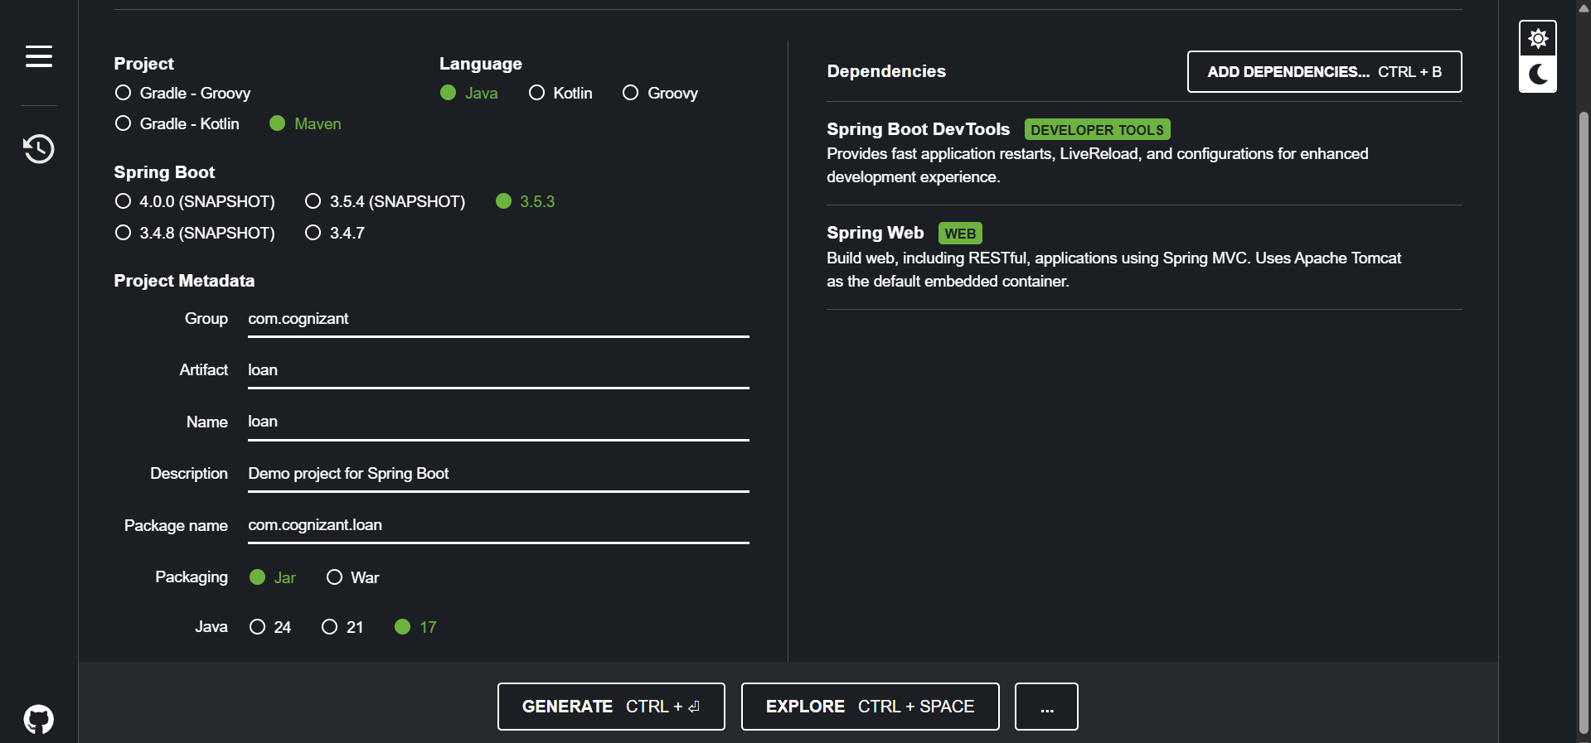

Generate → Download → Extract → Move to → Microservice

Build loan Project

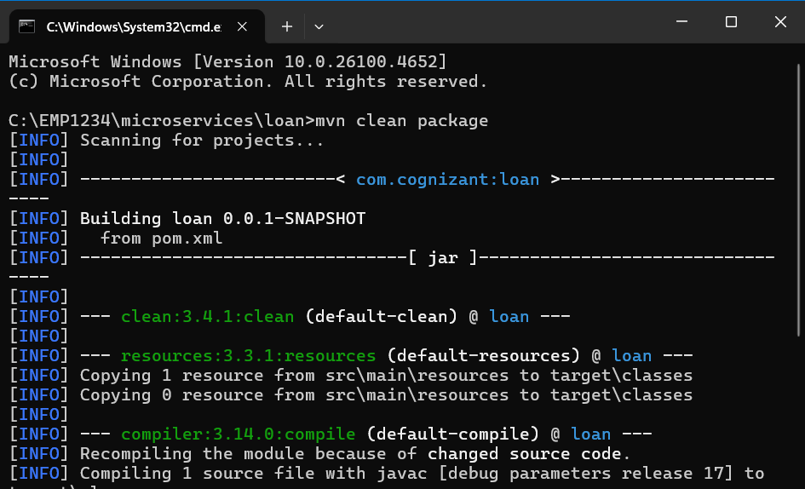

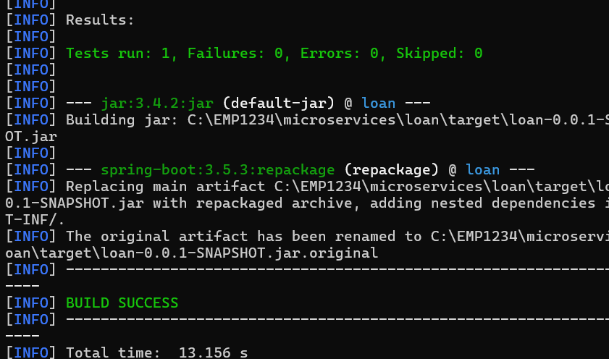

Import loan project in Eclipse

src/main/java/com.cognizant.loan/LoanController

package com.cognizant.loan;

import org.springframework.web.bind.annotation.GetMapping;

import org.springframework.web.bind.annotation.PathVariable;

import org.springframework.web.bind.annotation.RestController;

*@RestController*

public class LoanController {

*@GetMapping*("/loans/{number}")

public Loan getLoanDetails(*@PathVariable* String number) {

return new Loan(number, "car", 400000, 3258, 18);

}

static class Loan {

private String number;

private String type;

private double loan;

private double emi;

private int tenure;

public Loan(String number, String type, double loan, double emi, int tenure) {

this.number = number;

this.type = type;

this.loan = loan;

this.emi = emi;

this.tenure = tenure;

}

public String getNumber() { return number; }

public String getType() { return type; }

public double getLoan() { return loan; }

public double getEmi() { return emi; }

public int getTenure() { return tenure; }

}

}

LoanApplication.java

package com.cognizant.loan;

import org.springframework.boot.SpringApplication;

import org.springframework.boot.autoconfigure.SpringBootApplication;

*@SpringBootApplication*

public class LoanApplication {

public static void main(String[] args) {

SpringApplication.*run*(LoanApplication.class, args);

}

}

Using different port for loan

src/main/resources/application.properties

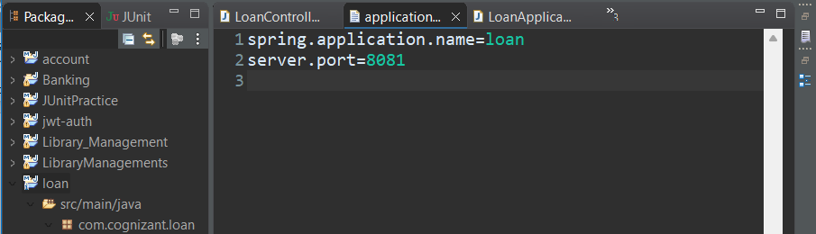

Run & Test loan Service

